Treasury Management - Workflow Functional Document

Application: | NGERP-CENTRA
WorkFlow: | Procure To Pay
WorkFlow Item Name: | Treasury Management

Description
Treasury Management refers to the Process of Financial Cash flow Process of Bank.

Work Flow Process:

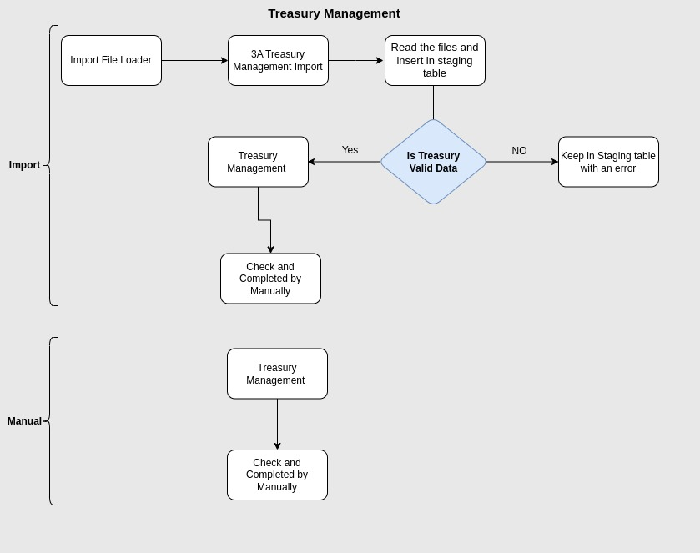

Business Rules:

- There are two ways to create treasury management
- Manual creation by user
- Import treasury through file loader
- This transaction will be done only in HQOW
- There are 8 Document types in Treasury management for manual creation
- Bank Withdrawal
- Bank to Bank
- Cash Trade to NonTrade
- Cash to Bank
- Deposit
- Deposit Encash
- Interest Income
- Interest Income Payable
- Only Three Document type alone can be imported through file loader.
- Bank to Bank
- Cash to Bank
- Interest Income
- Import Format Name Should Vary For Three Different Document Types.
- Format Should Be Either csv or xlsx
- If the import file contains an error, it will remain on the staging screen. Otherwise, it will move to the Treasury Management screen in the "Drafted" state.
- Bank to Bank :

When Two Different Business Partners have Sent Money through Bank to Bank For Different Regions Via Bank.

- Cash to Bank :
User Deposit Their On hand Cash To The Respective Bank.

- Interest Income :
This Refers To The Interest Amount Received From The Bank.

